WEEK 1

[Ravi Bramhadev Gavade](mailto:ravibramhadev.gavade@gwu.edu)

CSCI 4237

30th sept. 2024

Class Activities and Homework

Week 1 was a fun class! Going through the XML and Kotlin basics was so refreshing.

The homework is similar to what we did in the class. It is a fun and easy task to display a name and an image on the screen on a press of a button. I did add some additional functionality to the app as I was excited to do the homework. The clear button will simply remove the background gif(I found this lib from a GitHub, while I was doing some research for my app), and also hide the image and the textview. I also used the SDP(lib from Github) which makes the UI responsive. The clear button is not a button, it's a text view haha(which is initially hidden).

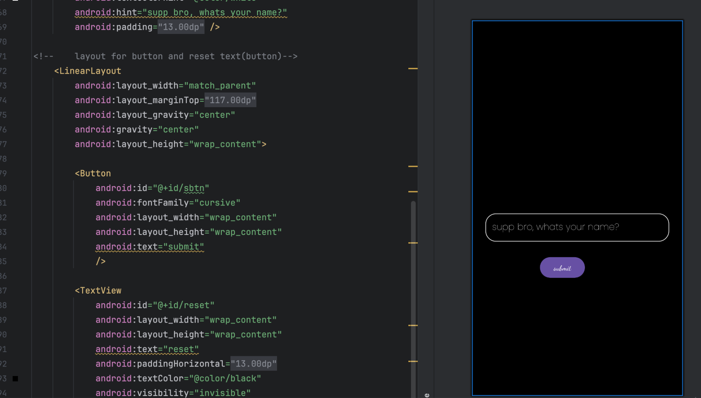

Recommendations/Feedback

As I mentioned before, the first class was fun, and I'd like to have the same experience for the whole semester.